7 AESTHETIC PINK VALENTINE'S DAY OUTFITS (THE VIBE CHECK)

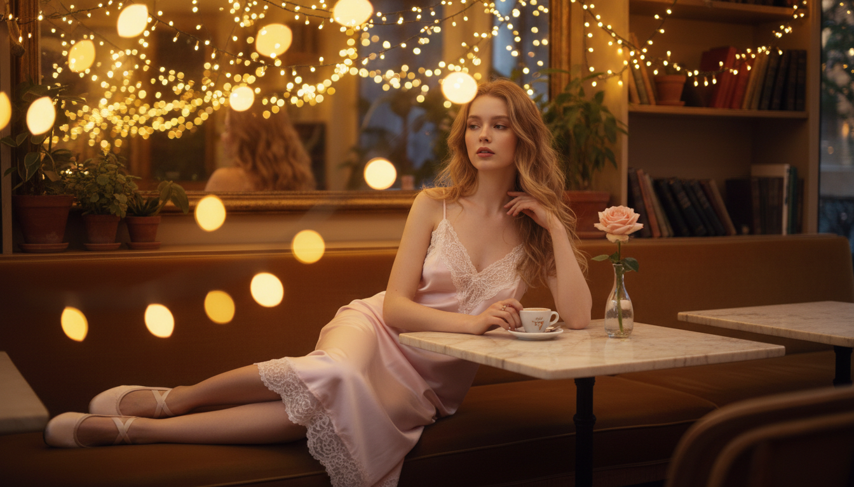

Valentine's Day is coming up fast and we are all about that soft girl aesthetic this year. Finding the perfect look can be stressful but pink is always the right answer for February 14. This list of 7 Aesthetic Pink Valentine's Day Outfits (The Vibe Check) will help you pick a look that matches your energy perfectly. You can go for hot pink for a bold statement or keep it sweet with pastel shades. Every outfit focuses on making you feel confident and cute for your dinner dates or movie nights. These styles are easy to copy and look amazing in photos. Check out these cute looks below.

# Baby Pink Slip Dress Valentine's Outfit

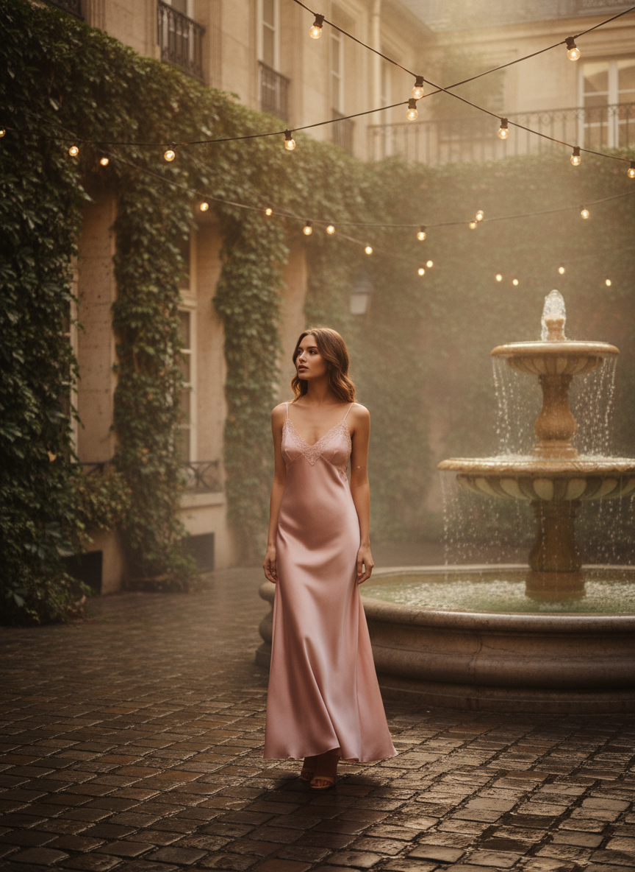

Wear a delicate silk slip in a soft baby pink shade for a classic romantic vibe. Pair it with an oversized white cardigan to keep it cozy while still looking put together, or dress it up with some gold jewelry. This pink outfit is perfect for a fancy dinner or a cute photo op with your friends.

# Hot Pink Knit Valentine's Outfit

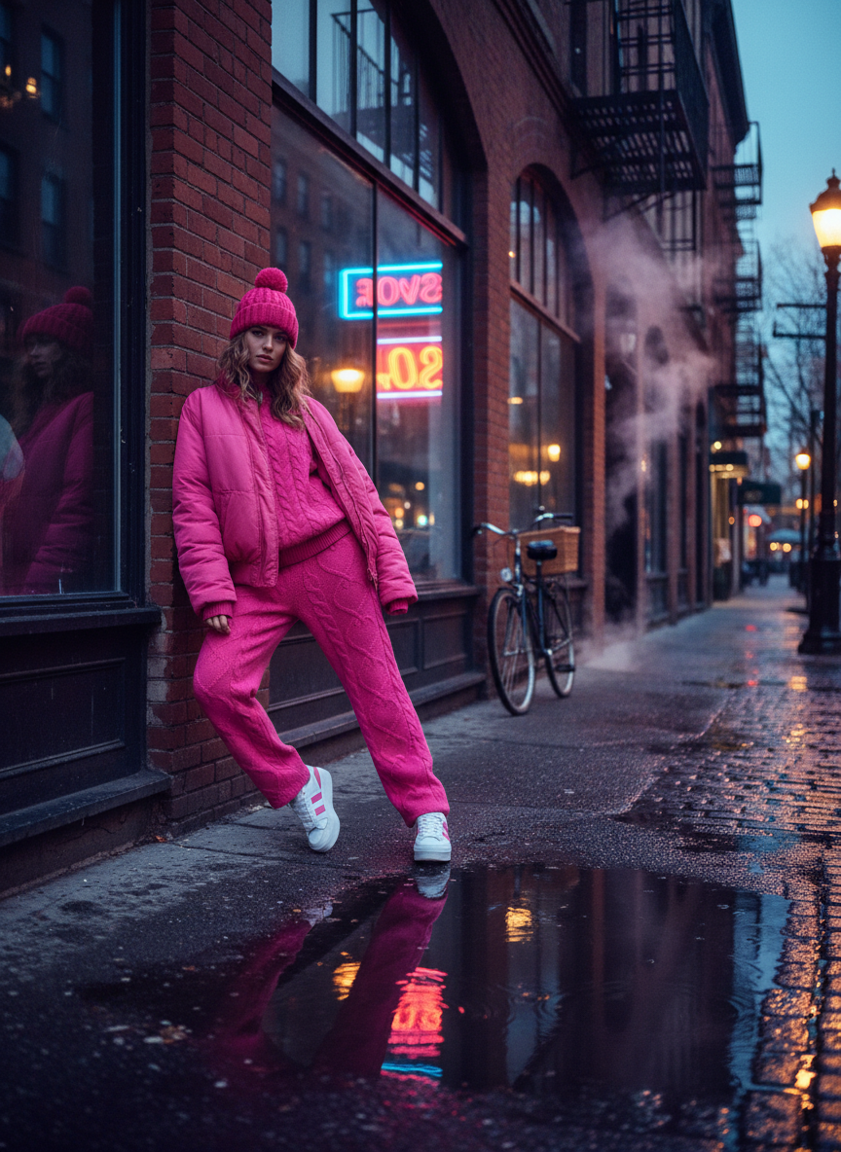

Grab a chunky knit in a bright hot pink color to make a huge statement. You should pair this with some black leather pants or a cute mini skirt to balance the baggy top. It feels super casual but looks like you tried really hard to put together a cool streetwear look. This pink outfit works great for a casual coffee date or walking around the city.

# Pink Pleated Skirt Valentine's Outfit

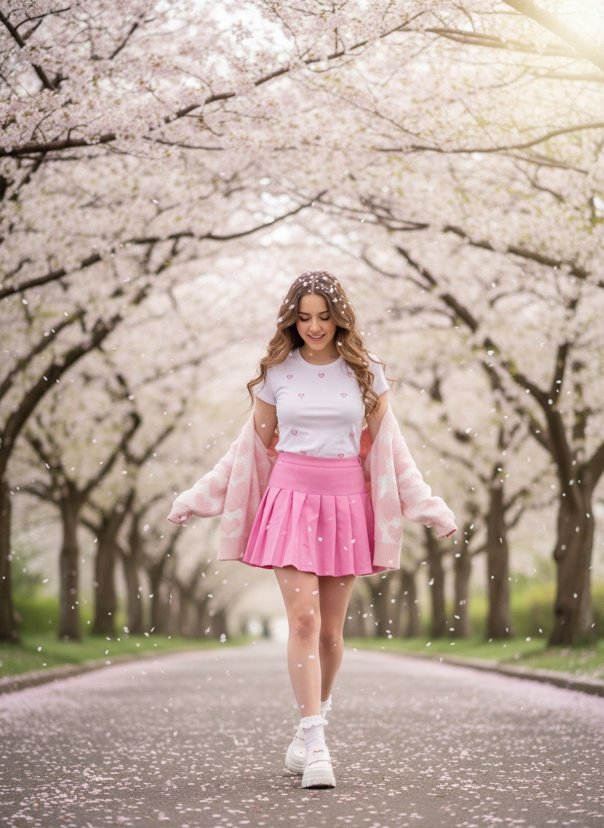

A pleated skirt in a pastel pink color gives off total schoolgirl chic vibes. You can add a white baby tee and some chunky loafers to finish the look. This pink outfit is very popular on social media right now and looks so clean in every single picture you take.

# Pink Denim Jacket Valentine's Outfit

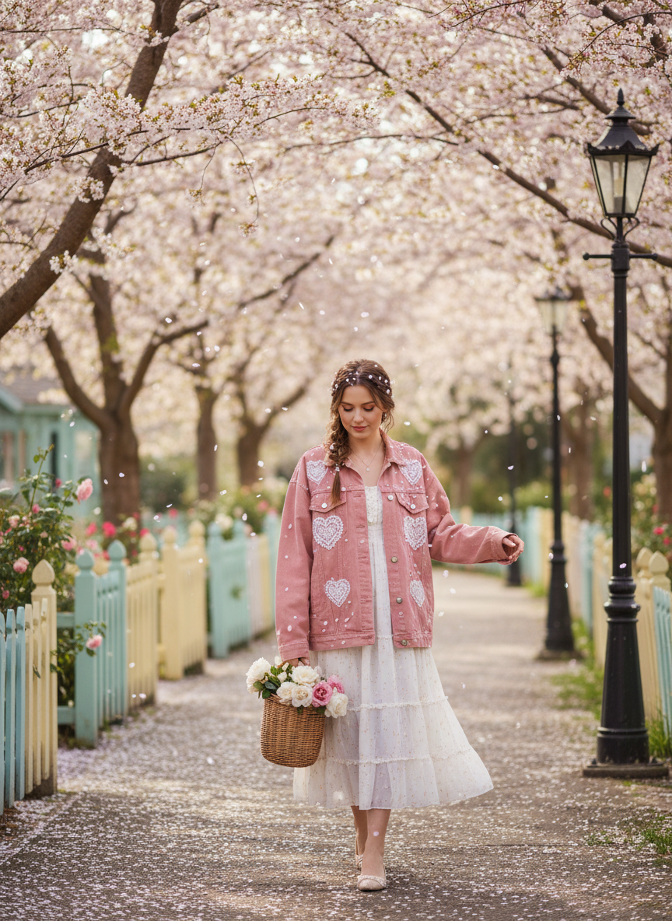

Switch up your usual blue denim for a bright pink denim jacket. You can wear this over a simple white dress to add a pop of color to a basic look. This pink outfit is great for a daytime date because it feels very relaxed and not too over the top.

# Pink Satin Midi Valentine's Outfit

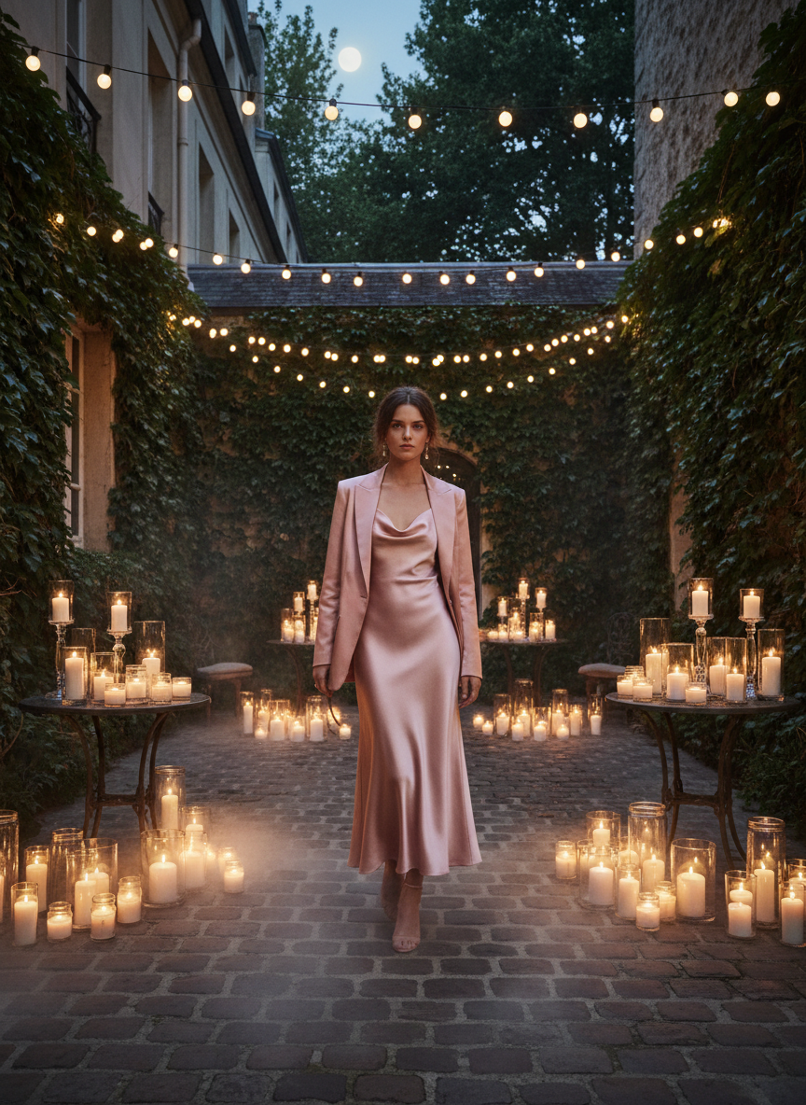

A satin midi skirt in a dusty pink shade looks very elegant and expensive. Wear it with a tight black turtleneck or a simple white bodysuit for a sleek silhouette. This pink outfit is a top choice if you want to look a bit more mature for your evening plans. It flows beautifully when you walk and looks amazing with some simple strappy heels.

# Pink Corset Top Valentine's Outfit

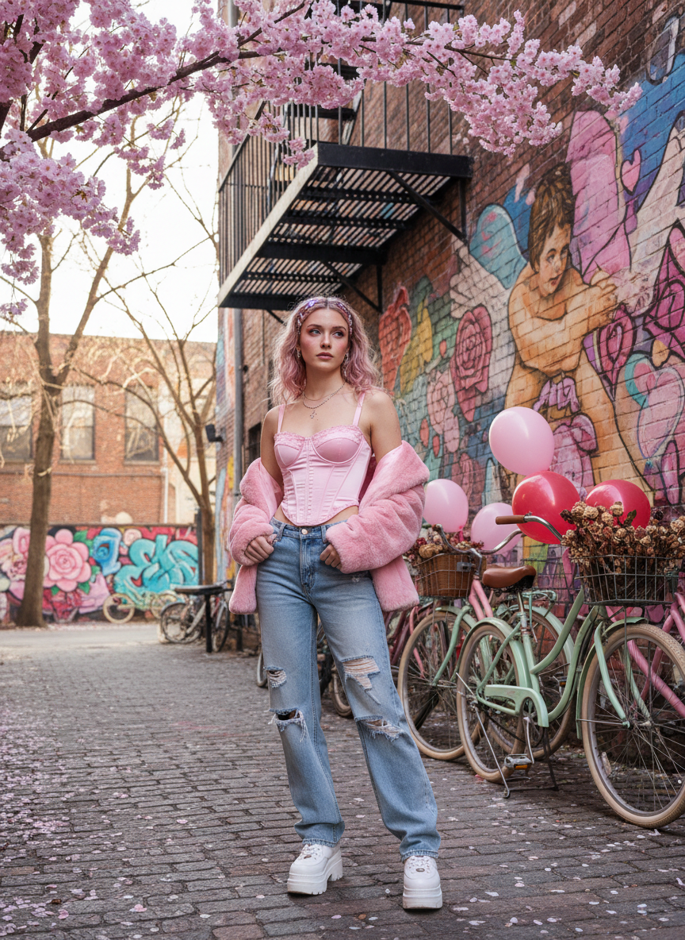

Corsets are everywhere right now and a pink corset top is the ultimate move for February. Combine it with some baggy light wash jeans to keep the look from being too formal. This pink outfit gives a perfect balance of feminine and edgy styles that everyone will love.

# Pink Lounge Set Valentine's Outfit

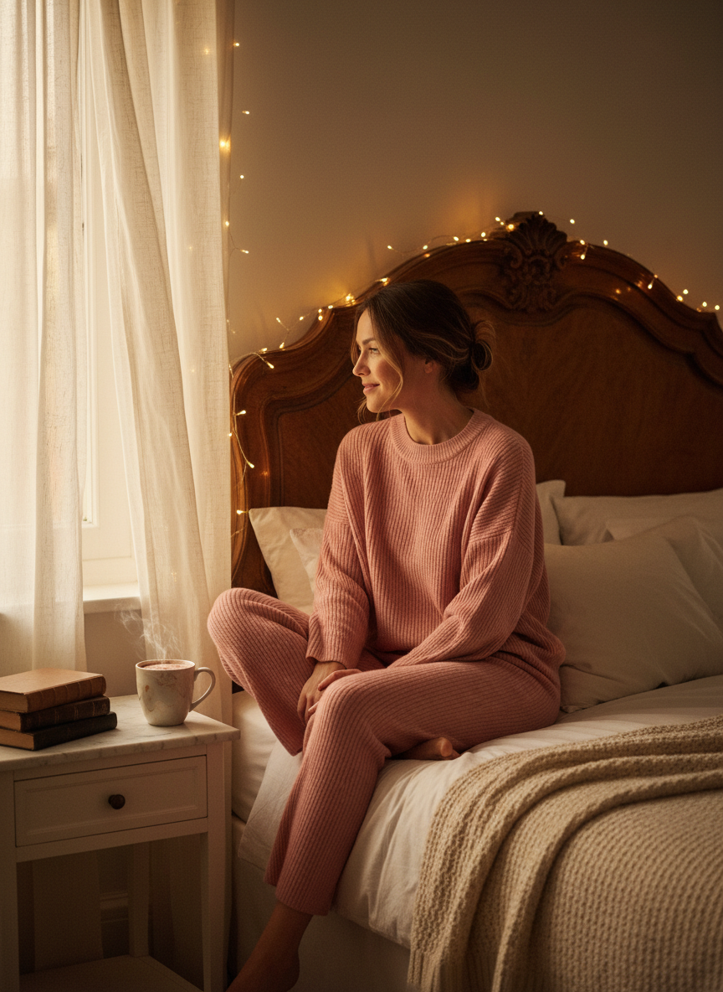

Staying in for the night is totally valid and you can still look cute in a pink lounge set. Look for a ribbed material or a fuzzy fabric in a blush pink color. This pink outfit ensures you stay comfortable while still being festive for the day even if you are just watching movies.

# Conclusion

Picking the right look for February 14th makes the whole day feel more special. These pink styles are easy to wear and fit any vibe you are going for this year. You deserve to feel cute and confident in whatever you choose to wear. Save these ideas to Pinterest now.